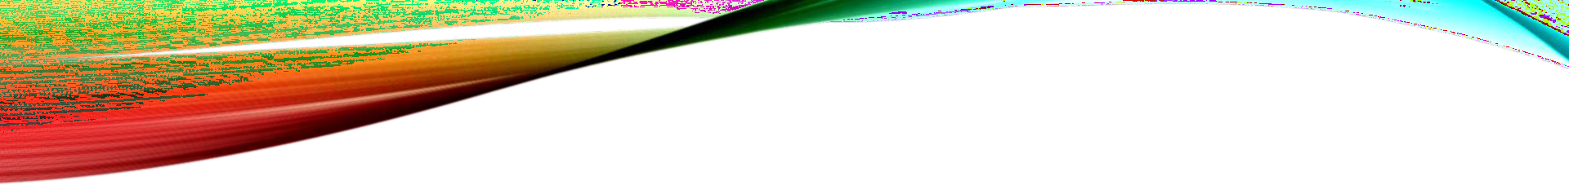
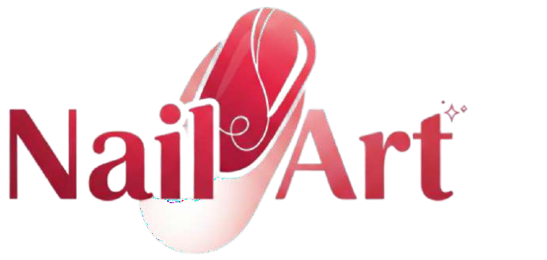
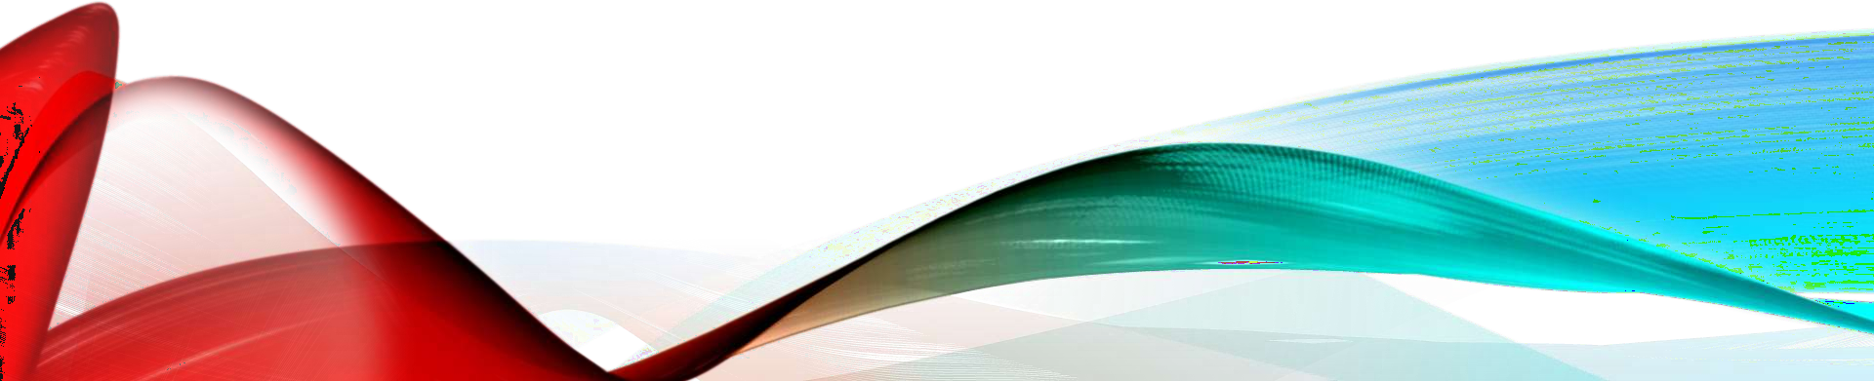

Presented By : Nail Art Web

USER GUIDE – NAIL ART

Introduction of Nail Art

Nail art is a creative and stylish way to decorate and beautify fingernails and toenails. It involves designing nails using colors, patterns, gems, stickers, and various artistic techniques. Nail art has become a popular form of self- expression and fashion, allowing individuals to showcase their personality and creativity through unique designs. From simple and elegant styles to bold and intricate artwork, nail art enhances overall appearance and adds a touch of confidence and charm. Today, nail art is widely used in salons, fashion shows, and everyday life as an important part of modern beauty trends.

USER GUIDE – NAIL ART

- Accessing the Website

Users can access the Nail Art website through any modern web browser such as Google Chrome, Microsoft Edge, or Mozilla Firefox. The website is designed to be user-friendly and responsive, allowing smooth access on desktops, laptops, tablets, and smartphones. By entering the website’s URL in the browser’s address bar, users can easily explore nail art designs, services, tutorials, and booking options. No special software is required, ensuring quick and convenient access for all users.

USER GUIDE – NAIL ART

Navigation Overview The Nail Art website has been designed with a simple and intuitive navigation system, allowing users to explore all sections easily

Home Page – Featured Products (Nail Paint) – Featured Products (Nail Art )
Shop Page - Premium Products Of Nail Paint And Nail Art
Blog Page – History Of Nail Paints Colors

Gallery - Nail Paint Collection – Nail Art Collection
About Us Page - Who We Are - Our Development Journey
Contact Us Page - Get in Touch - Send Us a Message – Geolocation
Feeback Page - Share Your Feedback
Login Page – Sign in / Log in

USER GUIDE – NAIL ART

Using the Features
Navigation Bar:
The Navigation Bar in Nail Art is located at the top of every page. It
helps users move easily between different sections of the website.
Upcoming Events:
The Upcoming Events section of Nail Artshows details about the latest and future Products or celebrations.
Map & Update:
The Update section of Nail Art helps users find the location of upcoming events and stay informed about the latest updates related to them. he Map allows users to view where different festivals or events will take place.

USER GUIDE – NAIL ART

Using the Features
Gallery:

The Gallery Page of Nail Art displays a collection of beautiful and colorful Nail Paint And Nail Art Images that represent joy.
Feedback:
The Feedback Section of Nail Art allows users to share their thoughts,
opinions, and suggestions about the website.
Login:
The Login Page of Nail Art allows registered users to sign in and access their accounts securely
Register:
The Register Page of Nail Art allows new users to create an account and join the website community

HELP & SUPPORT

For issues, contact the Campus Connect coordinators listed on the Contact Us page

Name | Student Id
Mohammad Minhal | Student1688167
Narand Chouhan | Student1684182
Abdul Rehman | Student1685088
Mohammad Haseeb | Student1683092
Ahmed Tariq | Student1683675



